- Purpose
  - The purpose of this document is to describe the procedure for assembling the Indicator LED Assembly. This is used for the SoliChem and the Wet Battery Protection systems.
- Scope
  - This SOP applies to all equipment assembly team members. The process applies to the following ID’s:
E12720 – Relay, Automotive SPST, 40A, 12 V
EP50222-06 – Sleeve, Exp Mesh, Black, 12”
E88924 – Terminal, 14-16 AWG, Q/D Male, FI, Blue
E12254 – Terminal, 14-16 AWG, Q/D Female, FI, Blue
E12718 – Terminal, 10-12 AWG, Q/D Female, FI, Yellow
EP50222-01 – Cut Wire, 14 AWG MTW, Black 2.5”
EP50222-02 – Cut Wire, 14 AWG MTW, Black 3.8”
EP50222-03 – Cut Wire, 14 AWG MTW, Red 2.5”
EP50222-04 – Cut Wire, 14 AWG MTW, Red 4.8”
EP50222-05 – Cut Wire, 14 AWG MTW, Green 3.5”

- Responsibilities
  - The operations manager/supervisor is responsible for enforcing this SOP.
- Materials
  - The proper materials needed for this process are listed on the machine work order.
- Definitions

- Procedure

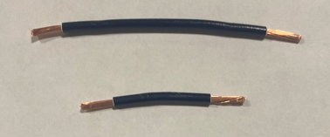
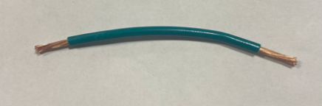
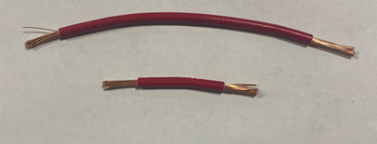
  - Cut 2 black wires 1 at 3.8” (EP50222-02) 1 at 2.5” (EP50222-01), cut 2 red wires 1 at 4.8” (EP50222-04) and 1 at 2.5” (EP50222-03) , and cut 1 green wire 3.5” (EP50222-05) then strip both ends.
3.5”
4.8”
2.5”
3.8”
2.5”

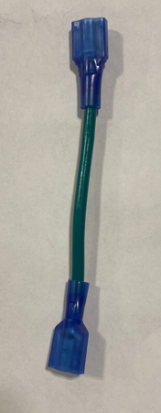
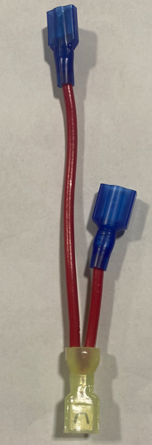
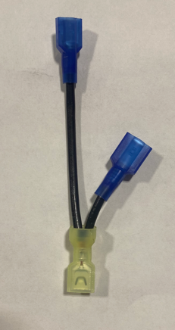
  - Take both black wires and line up the ends and twist them together. Then place them in yellow terminal and crimp. Then place a male blue terminal on the short wire and female terminal on the long wire. Repeat these steps for the red wire. Place female blue terminals on both ends of the green wire.

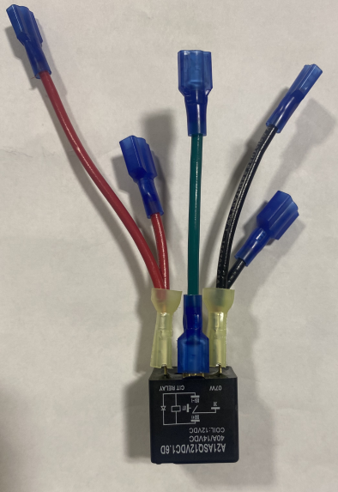
  - Place the wires on the relay (E12720). With relay picture facing you place the red wires on left, green on middle and black on right as shown in the picture below.
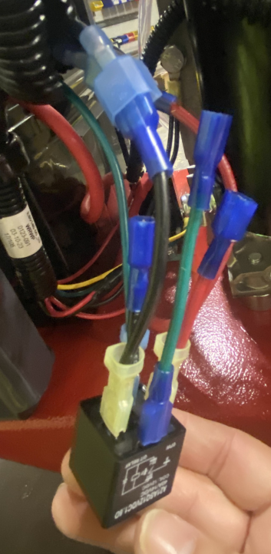
  - Cut and remove the tubing around the harness. Place the Green wire on the relay box. Next connect the long red wire to the blue wire from the harness, then connect the long black wire to the black wire from the harness.
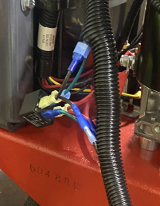

  - Connect the wires on the relay (E12720) to the corresponding color on the emission box. Turn the key to machine to test connection. Then place all the wires back in the tubing.

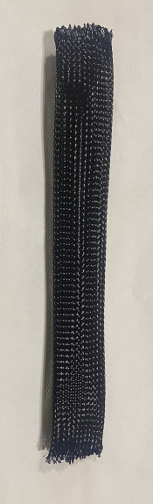
  - Cut the mesh sleeve to 12” (EP50222-06) and singe the ends with torch. Place the sleeve over the relay box and wires.
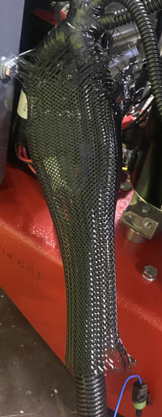

  - Attach emissions box to the machine. Then attach the emission box to the 02 sensor. Grab 4 wire ties place one on each end of the mesh, take another wire tie to secure 02 sensor wires, and last one to secure harness tube around wires.

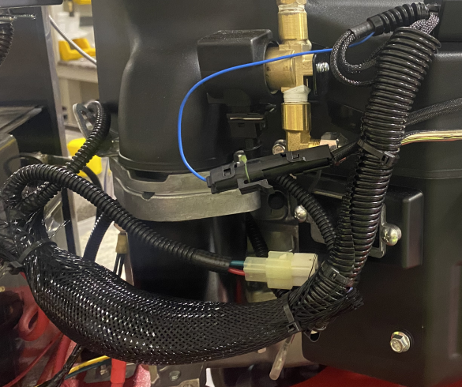

- References (optional section as needed)

- Training Guide

Functional Training Groups Requiring Training
Equipment Assembly Group

- SOP Change Control

Date of Change | Reason for Change
TBD | This is the first version of the S.O.P. hence there are no revisions to this document.

Approvals

Submitter/Author Approval:__________________________________ Date:______________________

Management Approval:______________________________________ Date:______________________

QAU Approval:_____________________________________________ Date:______________________

